Question 1:
[org 0x0100]

jmp start

printKey:
push ax

pop bx ; bx=ax
push es
push ax
push cx
push di
mov ax, 0xb800
mov es, ax ; point es to video base
xor di, di ; point di to top left column
mov al, bl
mov ah, 0x07 ; normal attribute
mov cx, 2000 ; number of screen locations
cld ; auto increment mode
rep stosw ; clear the whole screen
pop di
pop cx
pop ax
pop es
ret

start:

mov ah, 0 ; service 0 – get keystroke
int 0x16 ; call BIOS keyboard service

cmp al,27
je exit

call printKey ; clear the screen

jmp start

exit:
mov ax, 0x4c00 ; terminate program
int 0x21

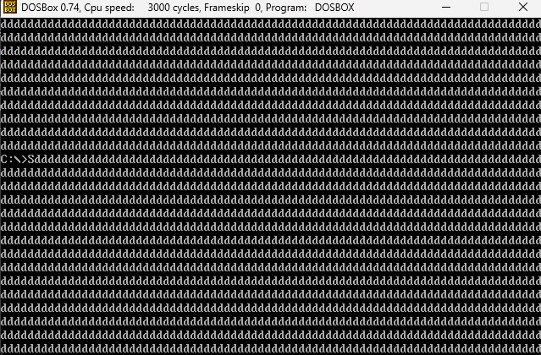

Question 2:
[org 0x0100]

mov ax, 0xb800
mov es,ax

mov ah,0
int 0x16

inc al
mov ah,0x70
mov di,160
mov [es:di],ax

mov ax,0x4c00
int 21h

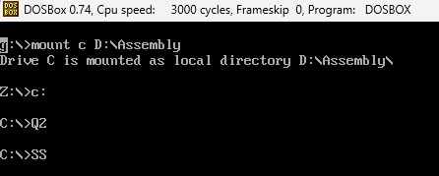

Question 3:
[org 0x0100]

jmp start

clrscr:
push di
push ax
push cx

mov si,di
xor di,di
mov ax,0x720
mov cx,2000

cld
REP stosw
mov di,si

pop cx
pop ax
pop di

ret

ISR_int_80h:
cmp al,'a'
je left_key

cmp al,'w'
je up_key

cmp al,'d'
je right_key

cmp al,'s'
je down_key

left_key:
sub di,2
jmp next

up_key:
sub di,160
jmp next

down_key:

add di,160
jmp next

right_key:
add di,2
jmp next

next:

iret

play:
mov ax,0xb800
mov es,ax
call clrscr

mov ah,0x70
mov al,'*'
mov word [es:di],ax

mov ah,0
int 0x16
cmp al,27
je exit
int 80

jmp play

start:

xor ax,ax
mov es,ax
mov word[es:80*4],ISR_int_80h
mov [es:80*4+2],cs
mov di,1080
call play

exit:
mov ax, 0x4c00
int 0x21

